LoRa
Attached to USART3
LoRa TX | USART3_RX (PB11)
LoRa RX | USART3_TX (PB10)
LoRA M0 | PC5
LoRA M1 | PB0
LoRa AUX | PB12

Baud 9600
USART3 and USART4 IRQ are common (shared)
Interrupt is enabled in CubeMX
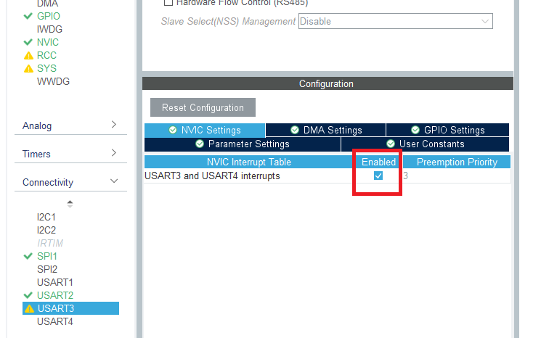
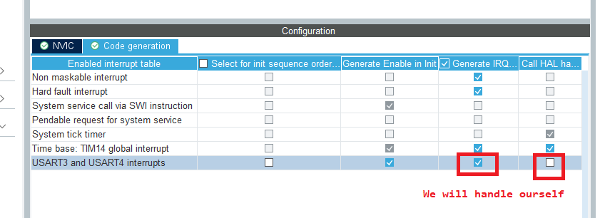

LoRa Configuration Code
A 6-byte packet defined at the start of the file lorae32_stm32.c
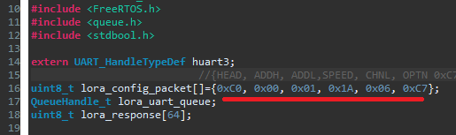
The LoRa E32 module has in built pullups on M0 and M1 pins, so by default they are in SLEEP mode. We must also make the associated GPIO pins in HIGH default state in CubeMX.
